**Project Report**

**On**

**“Food Waste Management”**

**Submitted By**

**Student Name: Saiful Islam Rishad**ID: 190122051

**Student Name: M Sazzad Sultani Roksi**ID: 190122063

**Student Name: Rifatul Islam**ID: 190122041

**Student Name: Tariqul Islam Rifat**ID: 190122050

**Student Name: Most. Sima Akter**ID: 190122015

**Supervised by**

**Jannatul Ferdaous**

Lecturer

Department of Computer Science and Engineering

**A project submitted in partial fulfillment of the requirements for the degree of Bachelor of Science in Computer Science and Engineering.**

**Department of Computer Science and Engineering**

**European University of Bangladesh**

2/4, Gabtoli, Mirpur, Dhaka-1216

**CANDIDATES’ DECLARATION**

This is to certify that the work presented in this project, titled, “**Food Waste Management**”, has been done by us under the supervision of Jannatul Ferdaous.

We also declare that neither this project nor any part of this project has been submitted anywhere else for the award of any degree, diploma, or other qualifications.

Signature

--------------------

Saiful Islam Rishad

ID: 190122051

Signature

----------------------

M Sazzad Sultani Roksi

ID: 190122063

Signature

--------------------

Rifatul Islam

ID: 190122041

Signature

----------------------

Tariqul Islam Rifat

ID: 190122050

Signature

--------------------

Most. Sima Akter

ID: 190122015

**CERTIFICATE OF APPROVAL**

This project titled, “Food Waste Management”, submitted by the group as mentioned in the candidates’ declaration page has been accepted as satisfactory in partial fulfillment of the requirements for the degree B.Sc. in Computer Science and Engineering on 1st April 2022.

Signature of Supervisor:

----------------------------------------

Jannatul Ferdaous  
Lecturer

Department of Computer Science and Engineering

European University of Bangladesh, Dhaka, Bangladesh.

Signature of Chairperson:

---------------------------------------------

Md. Obaidur Rahman

Associate Professor and Chairperson

Department of Computer Science and Engineering

European University of Bangladesh, Dhaka, Bangladesh

**ACKNOWLEDGEMENT**

We would like to express our gratitude and appreciation to all those who gave us the opportunity to complete this report. A special thanks to our final year project coordinator, **Jannatul Ferdaous,** Lecturer, Department of CSE, European university of Bangladesh, whose help, stimulating suggestions, and encouragement, helped us to coordinate our project especially in writing this report. We would also like to acknowledge with much appreciation the crucial role of the staff of the computer science and engineering lab, who gave the permission to use all required machinery and necessary material to complete the project. Last but not least many thanks go to the head of the project, **Md. Obaidur Rahman**, Associate Professor, and Chairman, Department of CSE, European University of Bangladesh, who have given his full effort guiding the team in achieving the goal as well as his encouragement to maintain our progress on track. We would like to appreciate the guidance given by another supervisor as well as the plan, especially in our project presentation that has improved our presentation skills by their comment and tip.

**Table of Contents**

|  |  |  |
| --- | --- | --- |
| **SL No.** | **Chapter Name** | **Page No.** |
| 01 | Project Details Front Page | 1 |
| 02 | Candidates Declaration | 2 |
| 03 | Certificate of Approval | 3 |
| 04 | Acknowledgment | 4 |
| 05 | Table of Contents | 5 |
| 06 | List of Figures | 7 |
| 07 | Abstract | 8 |
| **Chapter 1: Introduction** | | |
| 1.1 | Introduction | 9 |
| 1.2 | Motivation | 10 |
| 1.3 | Objective | 10 |
| 1.4 | Expected Outcome | 10 |
| **Chapter 2: Background** | | |
| 2.3 | Related Works | 11 |
| 2.2 | Challenges | 12 |
| **Chapter 3: Requirement Specification** | | |
| 3.1 | Requirement Collection Analysis | 13 |
| 3.2 | Use Case Modeling and Description | 13 |
| 3.3 | Logical Data Model | 14 |
| 3.4 | Proposed Diagram | 15 |
| 3.5 | Design Requirements | 15 |
| **Chapter 4: Design Specification** | | |
| 4.1 | Front-End Design | 16 |
| 4.2 | Interaction Design and UX | 17 |
| 4.3 | Back-End Design | 17 |
| 4.4 | Implementation Requirements | 18 |
| **Chapter 5: Implementation and Testing** | | |
| 5.1 | Implementation of Database | 19 |
| 5.2 | Implementation of Front-end Design | 19-33 |
| **Chapter 6: Advantage and Disadvantage** | | |
| 6.1 | Advantage | 34 |
| 6.2 | Disadvantage | 34 |
| **Chapter 7: Conclusion and Future Scope** | | |
| 7.1 | Discussion and Conclusion | 35 |
| 7.2 | Scope for Further Developments | 36 |
| **References** | | 37 |

**List of Figures**

|  |  |  |
| --- | --- | --- |
| **SL No.** | **Figure Name** | **Page No.** |
| 3.1 | Requirement Collection and Analysis | 13 |
| 3.2 | Use Case Modeling and Description | 14 |
| 3.3 | Logical Data Model | 14 |
| 3.4 | Proposed Diagram | 15 |
| 4.1 | Front-End Design (Splash Screen) | 16 |
| 4.2 | Interaction Design and UX | 17 |
| 5.1 | Login | 20 |
| 5.2 | Signup | 21 |
| 5.3 | Donor Dashboard | 22 |
| 5.4 | Agent Dashboard | 23 |
| 5.5 | Create Donation Post | 24 |
| 5.6 | Food Types | 25 |
| 5.7 | Pending Post (Donor End) | 26 |
| 5.8 | Pending Post (Agent End) | 27 |
| 5.9 | Food collection process by an agent in the post description page | 28 |
| 5.10 | Food collection is completed by an agent on the post description page. | 29 |
| 5.11 | Collected Food | 30 |
| 5.12 | User Profile | 31 |
| 5.13 | About | 32 |
| 5.14 | Blog | 33 |

**ABSTRACT**

There is growing evidence that a significant share of global food is thrown away, with concomitant detrimental repercussions for sustainability. Reducing food waste is a key sustainability challenge for the food service industry. Despite the significance of this issue to the global foodservice industry, the link between innovation practices and food waste management has received limited attention in the academic literature. This application uses innovations in waste management. It is based on the evaluation of food waste solutions and innovations that combine strategic dimensions of waste management with practice-driven initiatives, including incremental and radical innovations. The project presents a range of waste management initiatives, showing that their implementation in the foodservice sector varies depending on management’s beliefs, knowledge, goals, and actions. The concepts discussed here could help practitioners to become more aware of the factors that drive the adoption of food waste innovations.

Chapter 1

Introduction

Food is a substance consumed to provide nutritional support for organisms. It is usually of plant or animal origin, and contains essential nutrients, such as carbohydrates, fats, proteins, vitamins, or minerals. We need food to live. But we waste a lot of food in our daily life.

Across the world, there are restaurants that waste tons of excess food every day. Where millions of people remain hungry. Bangladesh is one of the most densely and highly populated countries in the world. A lot of foods get wasted by individual persons and restaurants of the country, where scarcity of food is very strong.

We have developed an android application to stablish a relation between restaurants or food donors and the charity organization as agents to enable excess food donation. Individual person also can donate wasted food through our application. Registered charity organization can pick up the wasted food which is donated by the restaurants or individual users. Then volunteers of the organization will serve the food among helpless and hungry people.

The availability of smartphone gave us the opportunity to carry advanced technology in our pocket. Almost every person checks their phone after waking up and plug the charger to charge the phone before sleeping. Because of technology, every single thing is becoming automated. Everything is becoming online from offline. Now a days, we are doing courses online, shopping via online and so on. There are a variety of end uses to food waste management. Food waste management is android application which will help to collect extra food from donor’s home, restaurants etc. The system is planned to consist of various useful features for the said purpose. Technically, we have learned Kotlin, XML, Firebase Authentication, Firebase Real-time Database by doing this project.

* 1. **Motivation**

Following are some of the motivations for this Food Waste Management:

There are many foodless people around the country. They can hardly afford food for their family and themselves as well. So, we took a step to reach food to those helpless people from the wasted food of the restaurant, community centers, and party centers.

* 1. **Objectives**

Some objectives are:

* Donors will post the food detail, pick location address, the number of people available for donated food
* Our agents will collect those foods from the pick address and reach the foodless people.
* Blogs can help humans with this application.

**1.3 Expected Outcome**

Through the application, foodless people will get food from restaurants and social events by agents. It will reduce food crises among the homeless and foodless people who live below the poverty level.

Chapter 2

Background

The Internet has changed the world in a significant way. In this modern world, we are becoming more and more dependent on online-based technology. We rely on the internet for each and everything in life. We have tried to make an android application named “**Food Waste Management**” which will reach the helpless people of our society easily.

**2.1 Related Works**

Food Waste Management is an android application that is implemented to provide service in the social and human rights sector. In Bangladesh, some of the examples of similar applications are nosh, OLIO, ShareTheMeal: Charity Donate, GoMkt, etc.

**OLIO**

OLIO gives the opportunity to share food and item preventing waste and saving money. It serves free stuff, borrows things, and shops homemade directly from neighbors [8].

**nosh**

With the nosh app, you can now track your food inventory, medicines, and expiry date or use by or best before date while you get recipe suggestions on your food inventory, do shopping planning, and reduce food waste in the household. nosh is powered by Artificial Intelligence (AI) which also keeps track of your food buying and wasting habits to reduce food waste and save money in the process [9].

**ShareTheMeal: Charity Donat**

ShareTheMeal is the charity app from the World Food Program that allows you to feed a hungry child with a tap on your phone. As the world faces a record number of emergencies, the rate of hunger is increasing. The good news is hunger is entirely solvable. ShareTheMeal is part of the United Nations World Food Program [10].

**GoMkt**

In New York City, goMkt connects restaurants that have unsold food with customers looking for discounts. By purchasing food as take-out through the app, customers save up to 75 percent off the original price—and reduce potential food waste. The business-to-consumer platform plans to expand to larger food businesses and connect them to charities, composters, and anaerobic digestion facilities [8].

**2.2 Challenges**

Every task has challenges. Some of the main challenges Food Waste Management are:

* Lack of internet connection might be our main challenge as Food Waste Management is an online application.
* We should build our application properly and make sure it works smoothly and is also user-friendly.

Chapter 3

Requirement Specification

In this chapter we are going to discuss about all the requirements tools and technologies that will be needed to complete the proposed system. Use case diagram and description and other requirements are described in this chapter.

**3.1 Requirement Collection Analysis**

The agent is a collector of donated food. They collect food from donors and deliver them to poor people. Donor handovers foods to agents.

* View Food Posts
* Collect food from donor
* Deliver those foods to poor people

Agent

Donor

* Register as donor
* Create food post
* Handover foods to out agents

Figure 3.1: Requirement Collection and Analysis.

**3.2 Use Case Modeling and Description**

A use-case model is a model of how different types of users interact with the system to solve a problem.

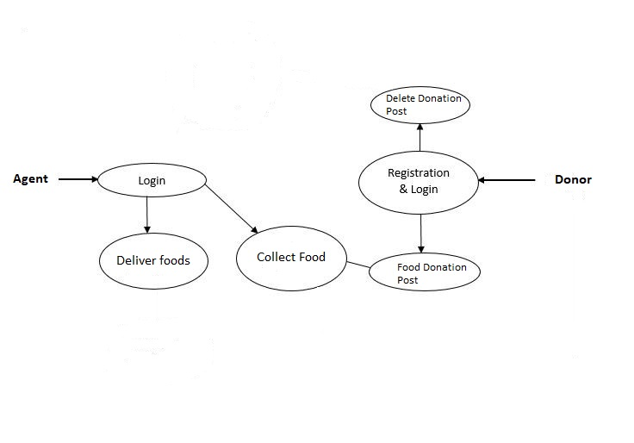

Figure 3.2: Use Case Modeling and Description

**3.3 Logical Data Model**

API will be called and the response will be sent to the application which is shown in the Logical Data Model figure and it will be the current time responsible. Data will transfer from database to android application.

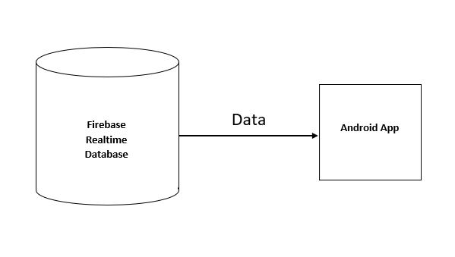

Figure 3.3: Logical Data Model

**3.4 Proposed Diagram**

Database management, phone calls between agents and donors, application interface connectivity is shown below.

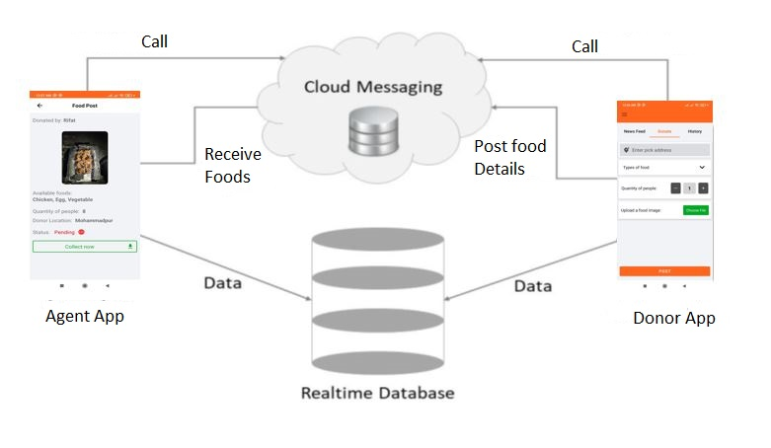

Figure 3.4: Proposed Diagram

**3.5 Design Requirements**

Design requirements are very important for mobile applications. It attracts the user to use it. So, to complete the design, we must have mobile application design skills. For this, we have to know the various types of computer programming languages and design tools like AdobeXd. Market analysis can be a good trick for the design. We have to give proper attention to designing the database so that it works appropriately and easily.

Chapter 4

Design Specification

In this chapter we are going to describe front-end design, UI/UX interaction, back-end design.

**4.1 Front-End Design**

Front-End is the place where the user interacts. So, considering this factor, we have created a user-friendly and smooth design. Every user can easily use this application.

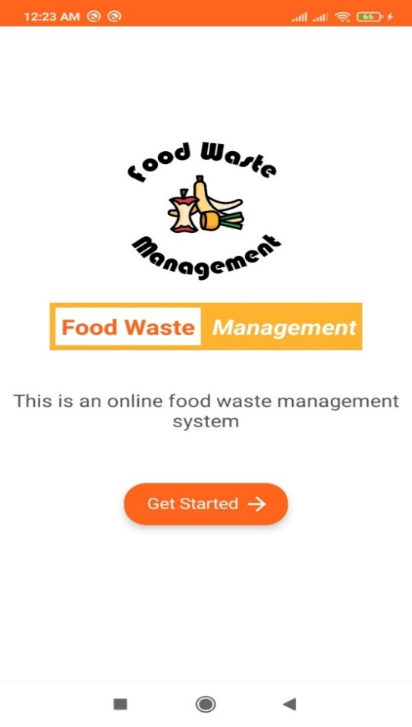

Figure 4.1: Front-End Design (Splash Screen).

**4.2 Interaction Design and UX**

We have tried to make our project UX design as simple as possible. Because we have researched on the internet and visited the various site, used various android applications. Then we made the UX design of our application.

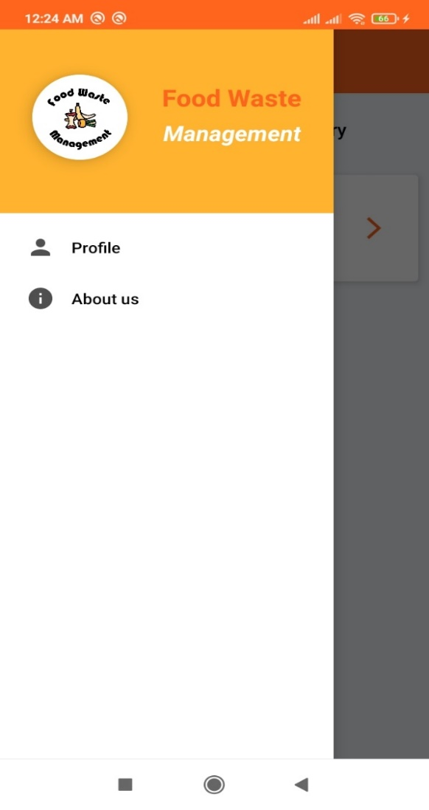

Figure 4.2: Interaction Design and UX

**4.3 Back-End Design**

Basically, in software development, back-end means rendering server-side. Usually, the backend programming consists of three parts: application, server, and database. For the backend, we have used technologies that are Kotlin, Firebase Realtime Database, and Firebase Cloud Storage.

**4.4 Implementation Requirements**

It was our social and human right related work. So, we had to learn a lot of new technologies and spent a huge time to fulfill all the requirements.

Chapter 5

Implementation and Testing

In this chapter the procedure of backend code and database implementation and interaction with front-end UI design and testing is described.

**5.1 Implementation of Database**

Implementation of the Database was fundamental for this application. In this project, we have used Non-SQL Database Firebase in real-time. The database returns an efficient and good amount of data for its data model.

**5.2 Implementation of Front-end Design**

Front-end design is very essential because of its visualization to the users. Developing a design for an application, we have to consider the user-friendly and smooth front end. It is very difficult to make the perfect design that attracts all.

**Login**

User login with phone number and password.

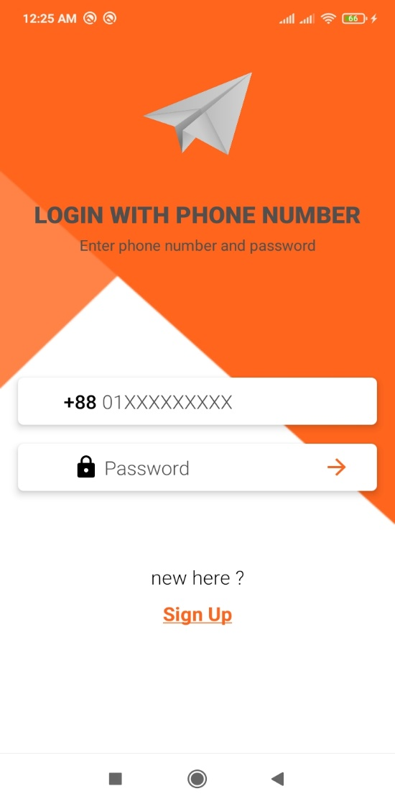

Figure 5.1: Login

**Signup**

User signup with a username, email, phone number, password, and user type (donor/agent).

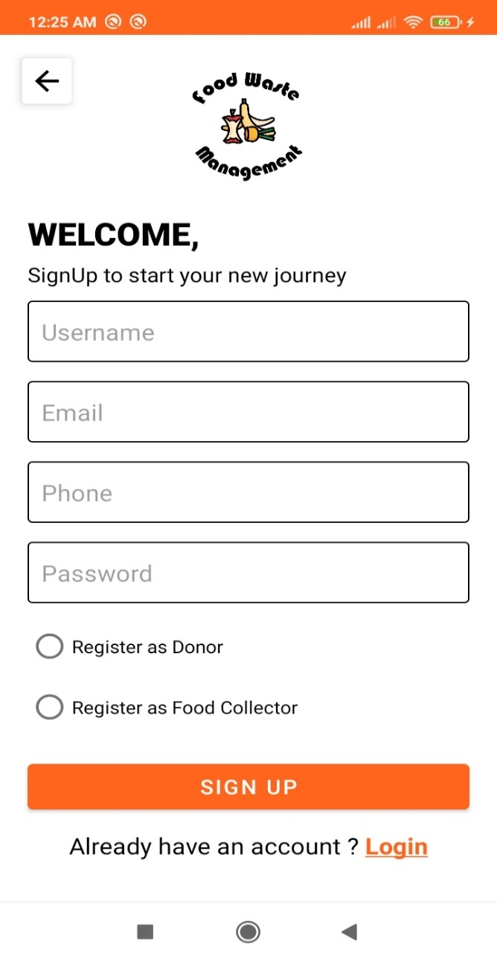

Figure 5.2: Signup

**Donor Dashboard**

On the Donor dashboard page user will see all food donation posts in the newsfeed.

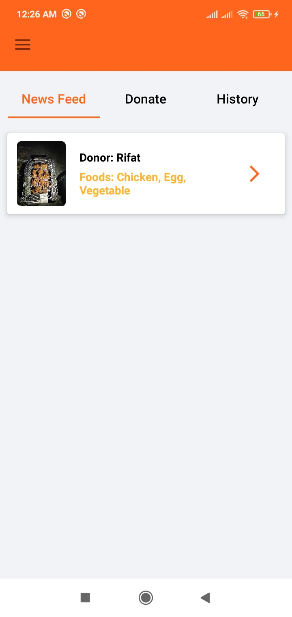

Figure 5.3: Donor Dashboard

**Agent Dashboard**

On Agent, dashboard page users will see all food donation posts in the newsfeed.

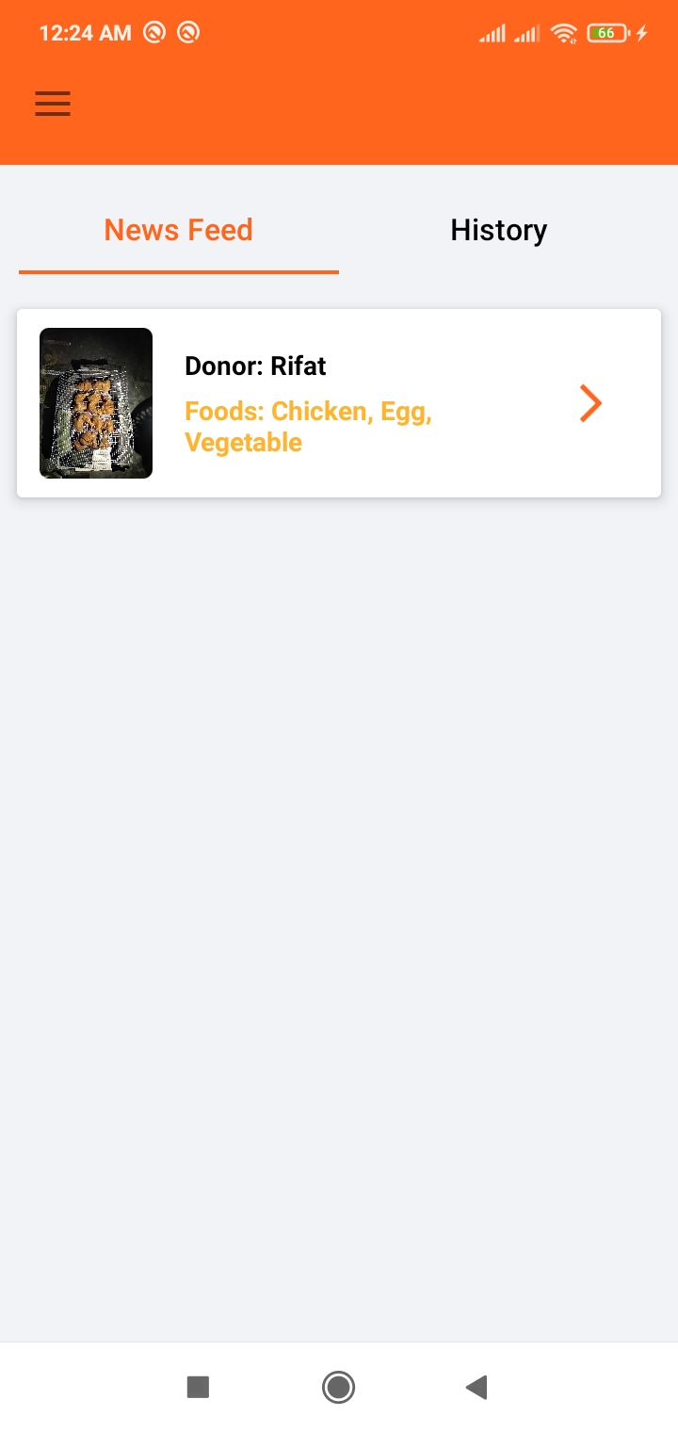

Figure 5.4: Agent Dashboard

**Create Donation Post**

Donors can post the extra foods which they want to donate including pick address, food types, available for people quantity, and food image.

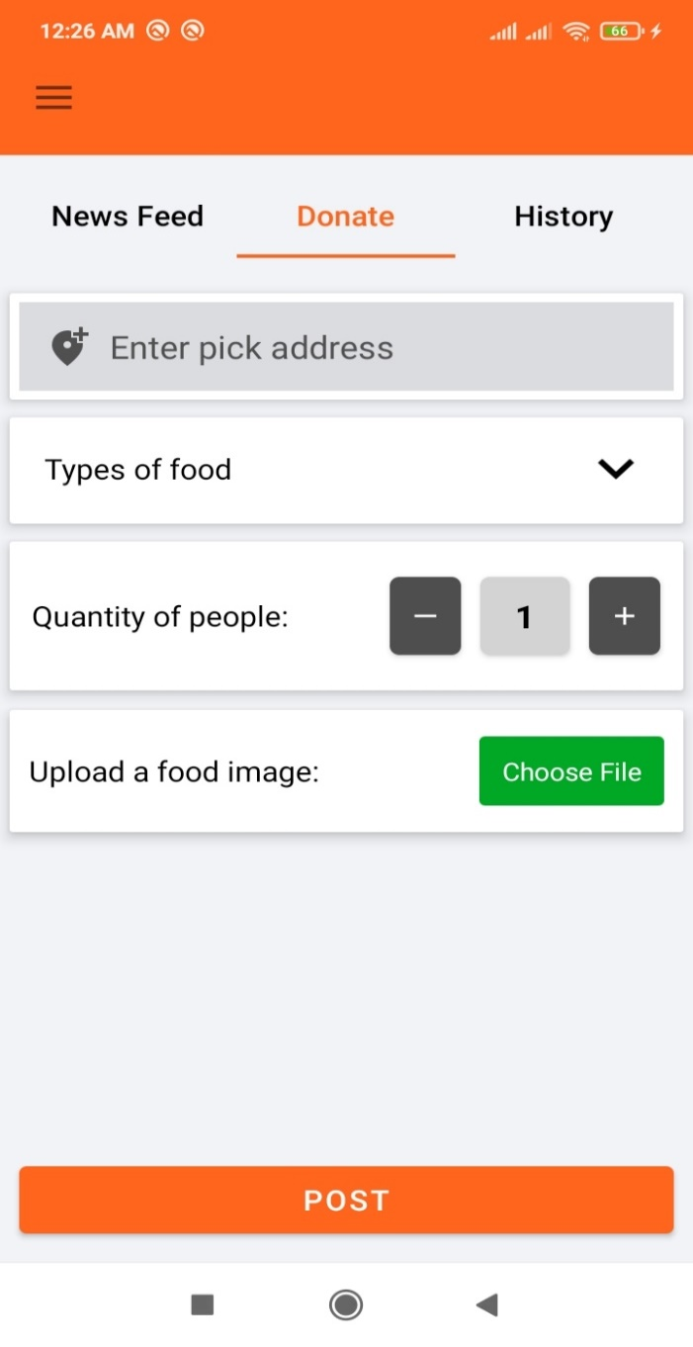

Figure 5.5 Create Donation Post

**Food Types in Donation Post**

Donors can select food types during creating a donation post.

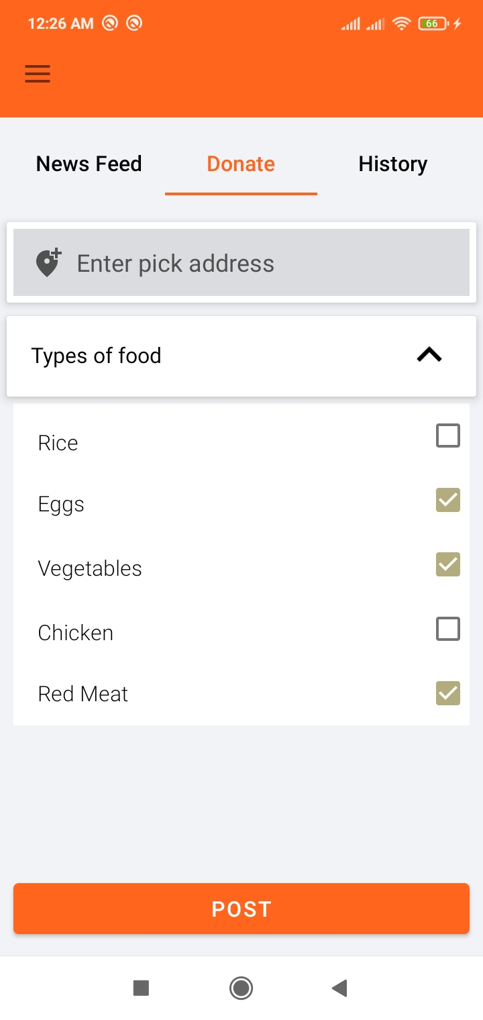

Figure 5.6: Food Types

**Pending Post (Donor End)**

Post description of pending post in donor end app.

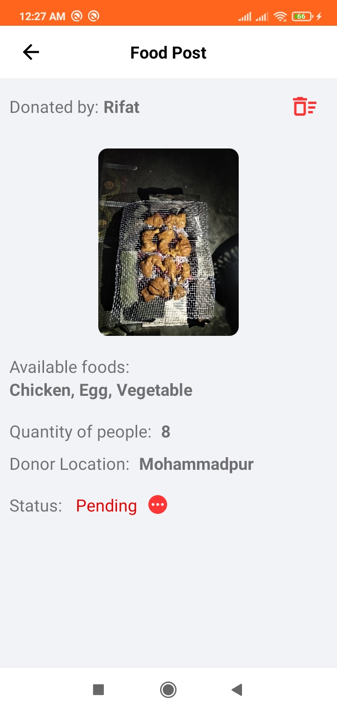

Figure 5.7: Pending Post (Donor End)

**Pending Post (Agent End)**

Post description of pending post in agent end app.

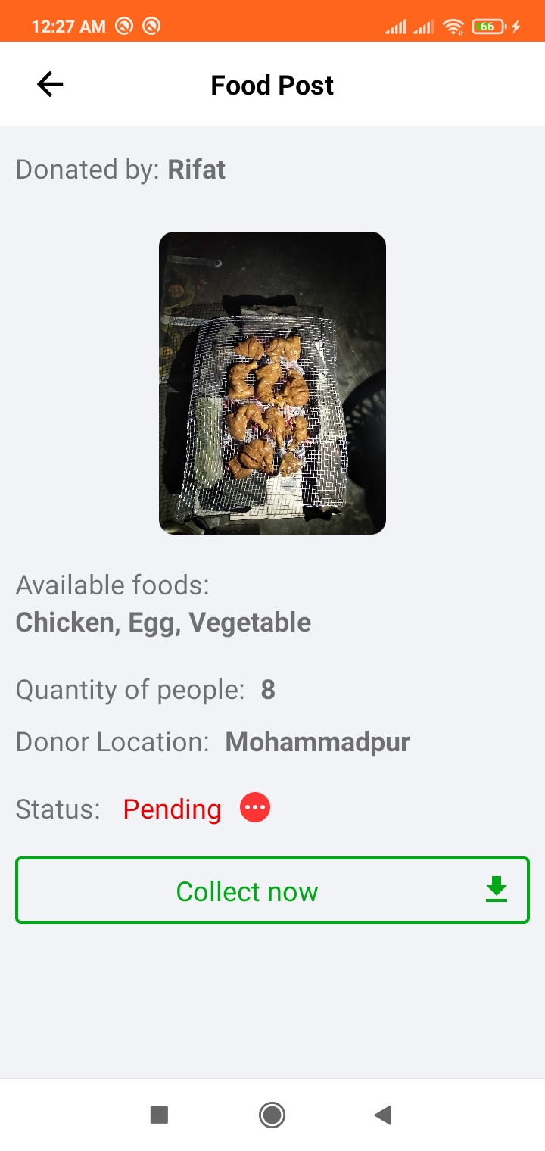

Figure 5.8: Pending Post (Agent End)

Continued…

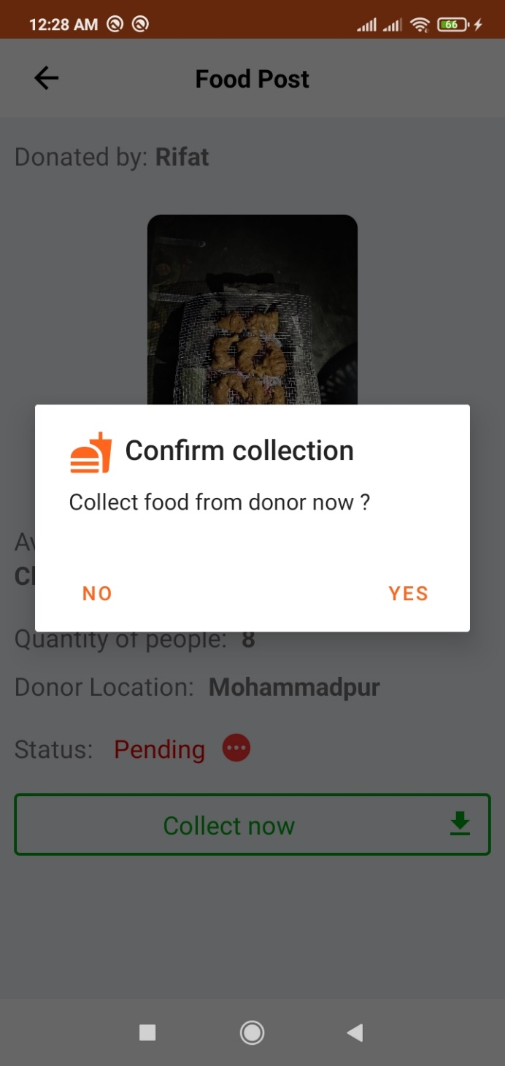

Figure 5.9: Food collection process by an agent on the post description page.

Continued…

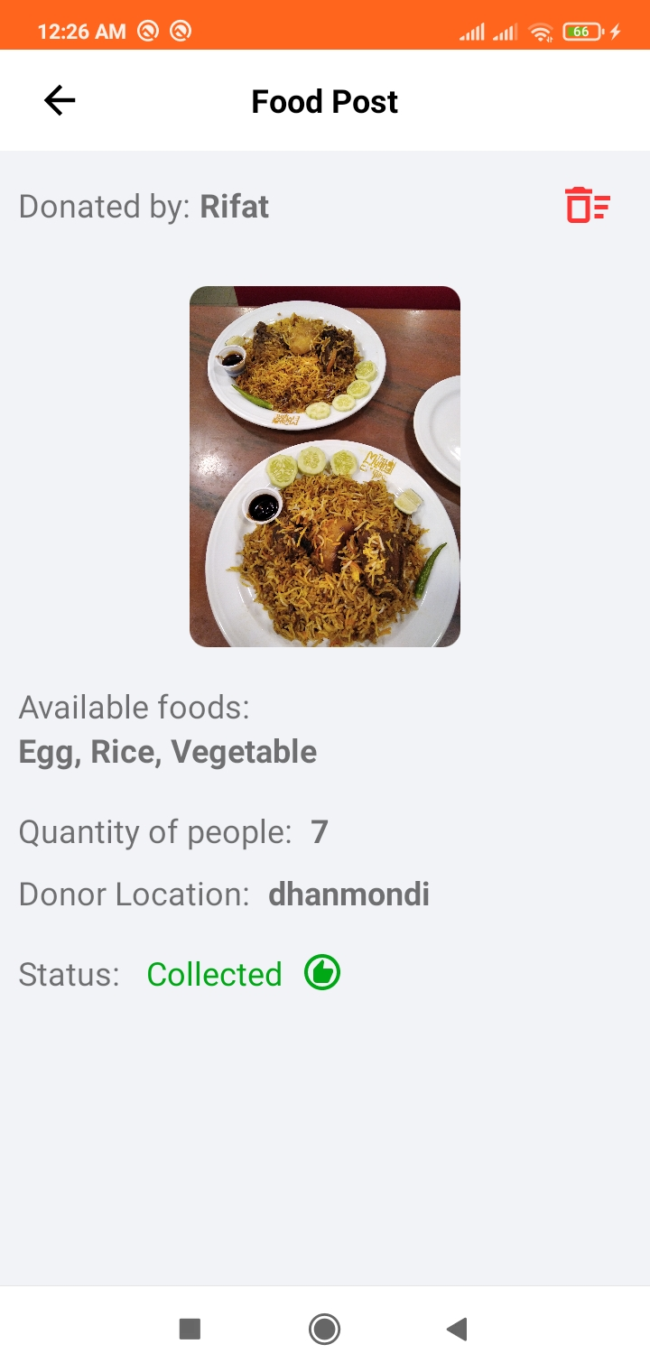

Figure 5.10: Food collection completed by an agent on the post description page.

**Collected food list in history**

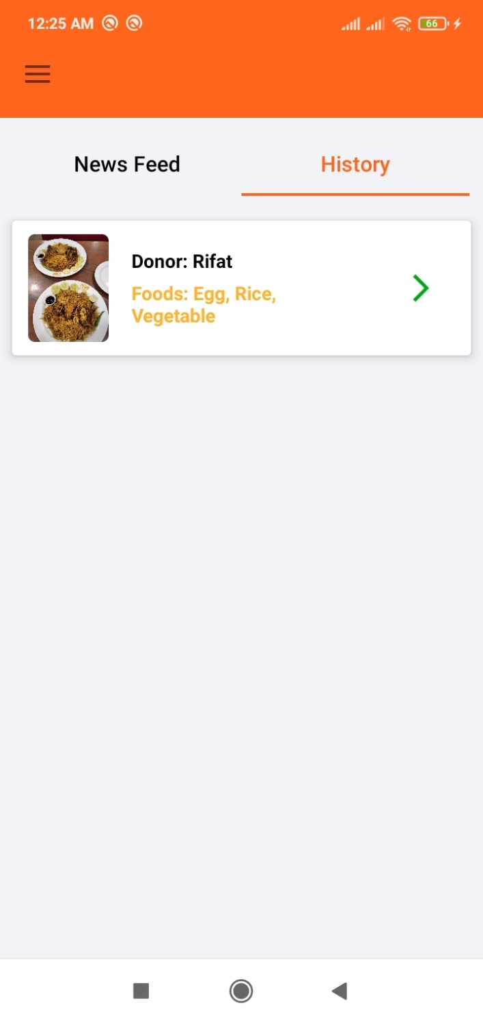

Figure 5.11: Collected Food

**User Profile**

Profile page contains username, email, address, phone number, logout option.

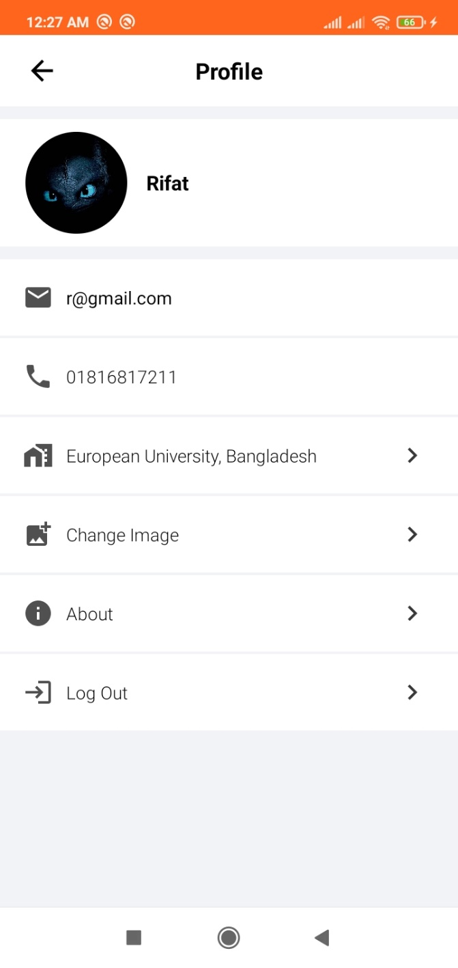

Figure 5.12: User Profile

**About**

About application and developers.

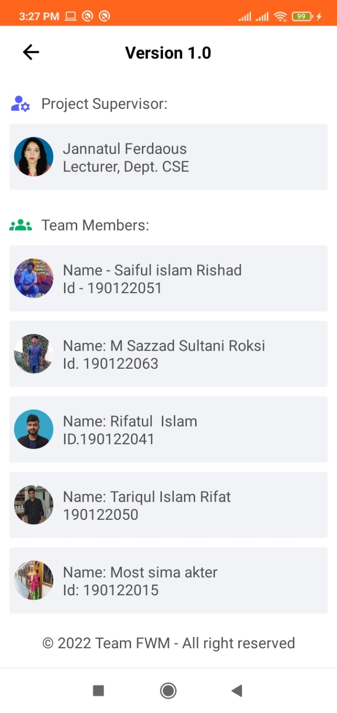

Figure 5.13: About

**Blog**

The blog page contains the procedures for donating and collecting foods through the application.

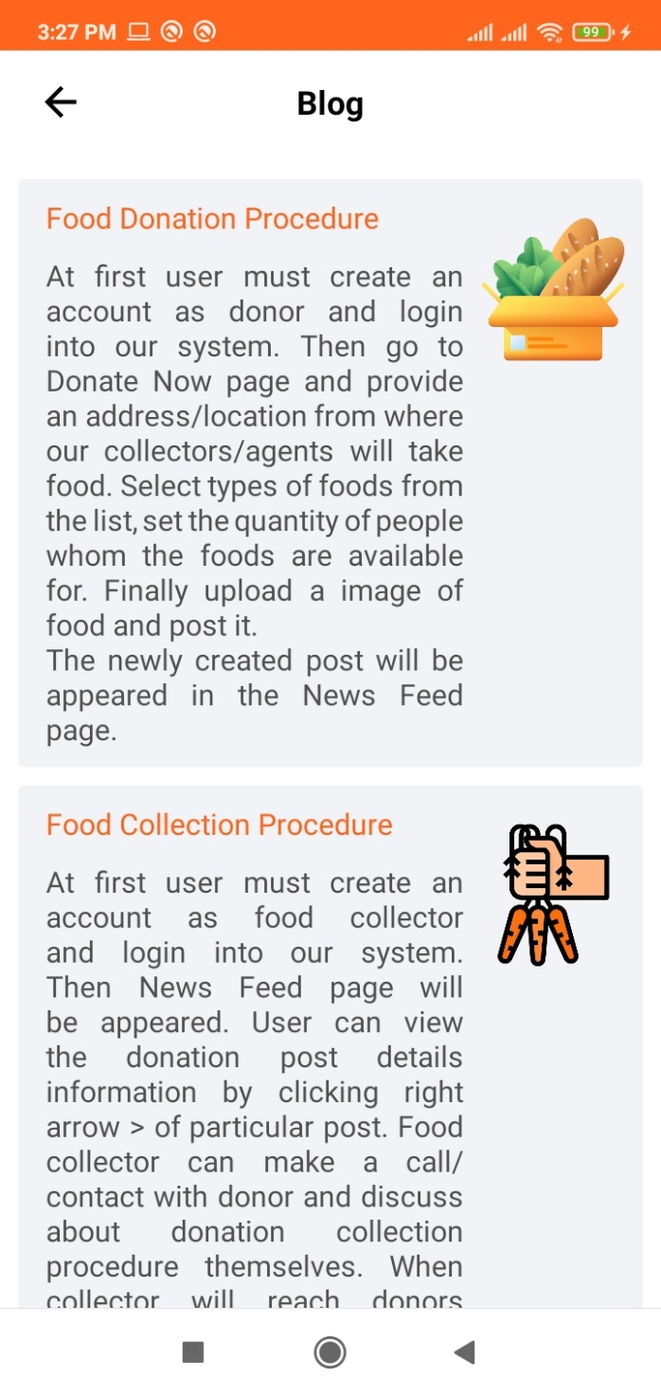

Figure 5.14: Blog

Chapter 6

Advantage and Disadvantage

No application is perfect. Besides advantages every system has some disadvantages. The advantages and disadvantages of our project are written below.

**6.1 Advantage**

This application will be beneficial for people of all occupations and ages. Users can perform a role to help poor and foodless people of this society through this application.

**6.2 Disadvantage**

During the development of the application, we have faced a lot of obstacles and successfully overcame most of them. Some of the obstacles were:

* We had to learn firebase and cloud storage for database.
* Getting the response from Database and display according to the design of the app.

Finally, after developing the project, we have successfully achieved:

* Food Waste Management and Donation application which will help many poor people who cannot eat properly or buy food.

Chapter 7

Conclusion and Future Scope

**7.1 Discussion and Conclusion**

The objective of this project was to implement approaches to waste management in the foodservice industry with the aim to identify innovations and to discuss their implications for food waste management. A key finding is that many companies are not actively innovating in the waste domain. They are however increasingly aware of the economic and social importance of food waste management. On the downside, the foodservice industry is not leading the way when it comes to innovation. As the study shows, there are only a few low- or zero-waste restaurants, a few chefs who are creating meals with 29 food scraps. This application consequently provides agents to deliver food to the poor, approach waste issues pertaining to food service firms.

This lack of clear, common definitions and consistency across studies might be one of the reasons why the foodservice sector lags behind other industries when it comes to food waste management. It also calls for tools and concepts to design innovative practices supporting effective waste management systems. Future development may address such tools and concepts, as well as different types of innovations and sources of cooperation between agents and traditional food service organizations.

**7.2 Scope for Further Developments**

Due to the limitation of time, knowledge, and experience, we couldn’t develop some features of our project. In the future, we want to develop those features one by one. Those features are:

* Push Notification to let the user know that agent is willing to collect his/her donated food.
* Publish the app on Play Store.

**REFERENCES**

[1] Understand the strategy of waste of foods, available at << <https://www.epa.gov/sustainable-management-food/sustainable-management-food-basics>>>, last accessed on 05-01-2022 at 12:00 P.M.

[2] Youtube for Android Tutorial, available at << <https://www.youtube.com/> >>, last accessed on 12-2-2022 at 10:00 A.M.

[3] Firebase, available at << <https://firebase.google.com/docs/guides> >>, last accessed on 03-01-2022 at 01:00 P.M.

[4] Material Design for Android, available at << <https://material.io/develop/android> >>, last accessed on 09-01-2022 at 12:00 A.M.

[5] Firebase Realtime Database integration in android studio, available at <<<https://firebasetutorials.com/create-firebase-realtime-database>>>, last accessed on 23-01-2022 at 12:00 A.M.

[6] Firebase Cloud Storage, available at << <https://firebase.google.com/docs/storage/android/start> >>, last accessed on 06-02-2022 at 12:00 A.M.

[7] Firebase Cloud Storage, available at << <https://firebasetutorials.com/use-firebase-storage> >>, last accessed on 21-02-2022 at 12:00 A.M.

[8] Firebase Cloud Storage, available at << [https://foodtank.com/news/2018/09/apps-preventing-food-waste](https://foodtank.com/news/2018/09/apps-preventing-food-waste0)>>, last accessed on 06-02-2022 at 12:00 A.M.

[9] Firebase Cloud Storage, available at << <https://www.oddbox.co.uk/blog/7-apps-that-are-helping-reduce-food-waste>>>, last accessed on 21-02-2022 at 12:00 A.M.

[10] ShareTheMeal a Charity Donation application, available at << <https://sharethemeal.org>>>, last accessed on 21-02-2022 at 12:00 A.M.